Course Three

Go Beyond the Numbers: Translate Data into Insights


Instructions
Use this PACE strategy document to record decisions and reflections as you work through this end-of-course project. You can use this document as a guide to consider your responses and reflections at different stages of the data analytical process. Additionally, the PACE strategy documents can be used as a resource when working on future projects.

Course Project Recap
Regardless of which track you have chosen to complete, your goals for this project are:
- Complete the questions in the Course 3 PACE strategy document
- Answer the questions in the Jupyter notebook project file
- Clean your data, perform exploratory data analysis (EDA)
- Create data visualizations
- Create an executive summary to share your results

Relevant Interview Questions
Completing the end-of-course project will help you respond to these types of questions that are often asked during the interview process:
- How would you explain the difference between qualitative and quantitative data sources?
- Describe the difference between structured and unstructured data.
- Why is it important to do exploratory data analysis?
- How would you perform EDA on a given dataset?
- How do you create or alter a visualization based on different audiences?
- How do you avoid bias and ensure accessibility in a data visualization?
- How does data visualization inform your EDA?
Reference Guide
This project has six tasks; the visual below identifies how the stages of PACE are incorporated across those tasks.
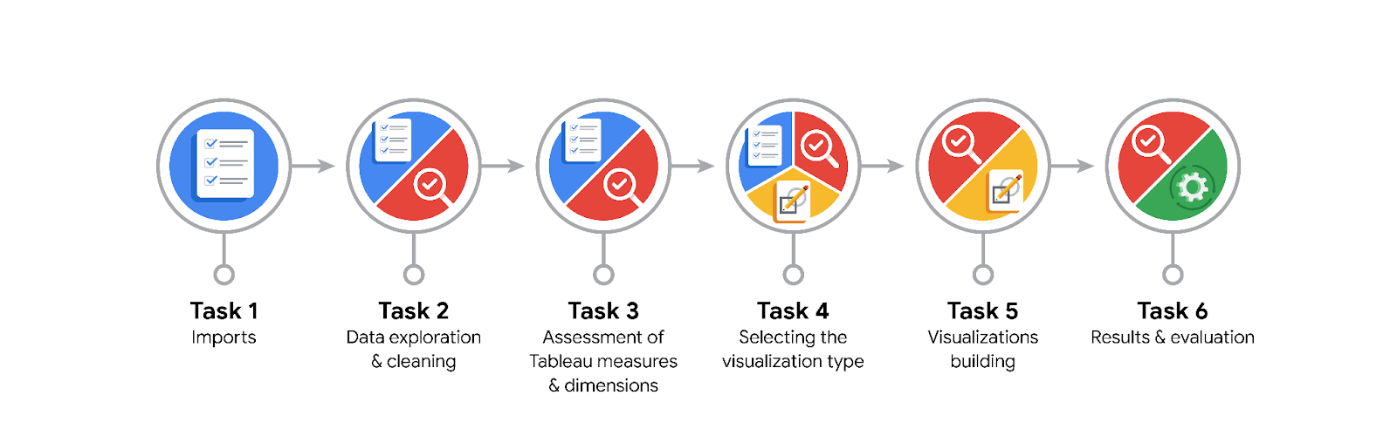
Data Project Questions & Considerations

PACE: Plan Stage
- What are the data columns and variables and which ones are most relevant to your deliverable?
The data columns are the following:
“Unnamed: 0", "VendorID", "tpep_pickup_datetime", "tpep_dropoff_datetime", "passenger_count", "trip_distance", "RatecodeID", "store_and_fwd_flag", "PULocationID", "DOLocationID", "payment_type", "fare_amount", "extra", "mta_tax", "tip_amount", "tolls_amount", "improvement_surcharge", "total_amount”
The following columns are those that are most relevant:
"tpep_pickup_datetime", "tpep_dropoff_datetime", "passenger_count", "trip_distance", "RatecodeID", "PULocationID", "DOLocationID", "payment_type", "fare_amount"

- What units are your variables in?
The units of the relevant variables are the following:
"tpep_pickup_datetime": datetime stored as string
"tpep_dropoff_datetime": datetime stored as string
"passenger_count": none (int)
"trip_distance": mile
"RatecodeID": none (int)
"PULocationID": none (int)
"DOLocationID": none (int)
"payment_type": none (int)
"fare_amount": USD

- What are your initial presumptions about the data that can inform your EDA, knowing you will need to confirm or deny with your future findings?
The fare amount is likely correlated with the pickup and drop-off dates and times, number of passengers, trip distance, rate code and the pick-up and drop-off locations.

- Is there any missing or incomplete data?
The dataset provided contains no missing values for any of the variables.

- Are all pieces of this dataset in the same format?
Yes

- Which EDA practices will be required to begin this project?
Discovering, cleaning, validating, structuring.

PACE: Analyze Stage
- What steps need to be taken to perform EDA in the most effective way to achieve the project goal?
- Identify the relevant variables and remove or ignore the others.
- Check for missing and invalid values,
- Identify potential outliers.
- Handle missing and invalid values as well as outliers.
- Visualize the data

- Do you need to add more data using the EDA practice of joining? What type of structuring needs to be done to this dataset, such as filtering, sorting, etc.?
There is no additional data that is required for addressing the problem at hand. However, to help with human comprehension of the data, it might be helpful to know the coordinates of the pick-up and drop-off locations and see them on a map.

- What initial assumptions do you have about the types of visualizations that might best be suited for the intended audience?
The primary goal is to understand the relationship between the fare amount and other variables for which information has been collected. Therefore, a scatterplot showing the fare amount versus another variable, such as trip distance, passenger count or drop-off location, might be useful.
Additionally, just to get a better idea of the distribution of the variables contained in the dataset, using histograms or boxplots would be helpful.

PACE: Construct Stage
- What data visualizations, machine learning algorithms, or other data outputs will need to be built in order to complete the project goals?
In terms of visualization, scatter plots and boxplots will be useful. Regression analysis between fare amount and other numerical variables will be useful to perform.

- What processes need to be performed in order to build the necessary data visualizations?
Data discovery, data cleaning, and structuring.

- Which variables are most applicable for the visualizations in this data project?
Fare amount and trip distance. RateCodeID, drop-off and pick-up locations, and the pick-up and drop-off datetimes could all be useful as well.

- Going back to the Plan stage, how do you plan to deal with the missing data (if any)?
As there are no missing values, no action needs to be taken regarding missing data.

PACE: Execute Stage
- What key insights emerged from your EDA and visualizations(s)?
There is a positive correlation between total amount and trip distance. This means there is a similar correlation between fare amount and trip distance.
The month and day of the week

- What business and/or organizational recommendations do you propose based on the visualization(s) built?
Build a model that predicts the fare amount based on the distance of the trip the customer wants to make.
The influence of the other variables that were retained should be assessed quantitatively before deciding whether to include them in the model.

- Given what you know about the data and the visualizations you were using, what other questions could you research for the team?
Where are the most popular pick-up and drop-off locations geographically situated? Is there a lack or excess of taxis on certain days of the week or during certain months? (Note that this requires data on taxi occupation rate.)

- How might you share these visualizations with different audiences?
While all visualizations could be shared internally with the rest of the team, only the most important ones should be shared with the client and Automatidata management.

